SUPERVISION
Date / time: 23/10/2025

Main issues discussed
- Overall evaluation of the proposal and its main issues. Overall, it is good and promising. The main issue is the writing: the language is too complex, the literature review is too short, it moves into specific model details too early, and the scope is not broad enough.
- What a literature review should cover and how it should be written. Start from the problem space and do not assume the reader already knows the topic. Good research writing should educate the reader and target an educated but non-specialist audience. It should answer key questions: why HAR is needed, why it is important or interesting, where and how it is used, how it is detected, what the current SOTA is, what research gaps remain, and how my study addresses these gaps. I should also read more literature reviews to learn how experts structure and write them.
- To achieve a high mark in the 40% project process component, I should continue submitting work early, keep reflecting and improving, and discuss my progress with my supervisor.

Work shown
The performance of kNN, Random Forest, and InceptionTime on the LARa dataset.
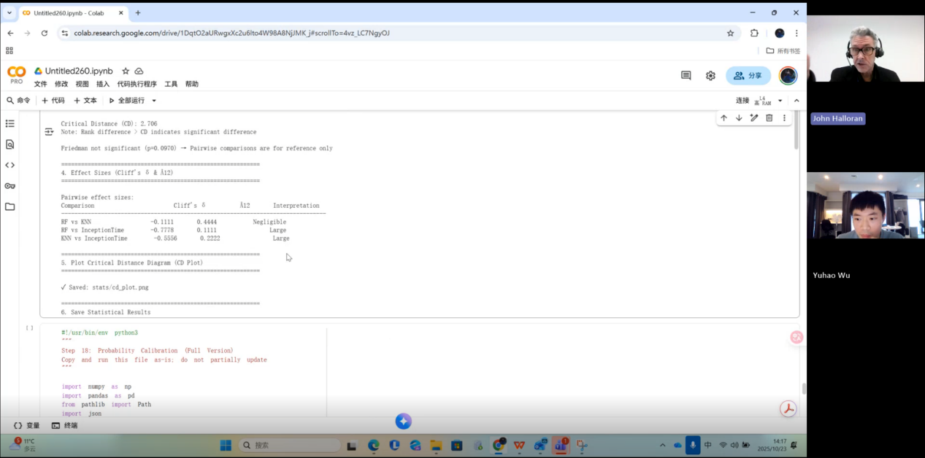
My supervisor’s advice: clearly explain the three models (their principles, the reasons for choosing them, and how they relate to the task).

Questions asked; how questions were answered
- Do I also need to write the proposal in a way that is friendly and easy to understand for non-experts?
Questions 2 and 3 are shown in the figure below:

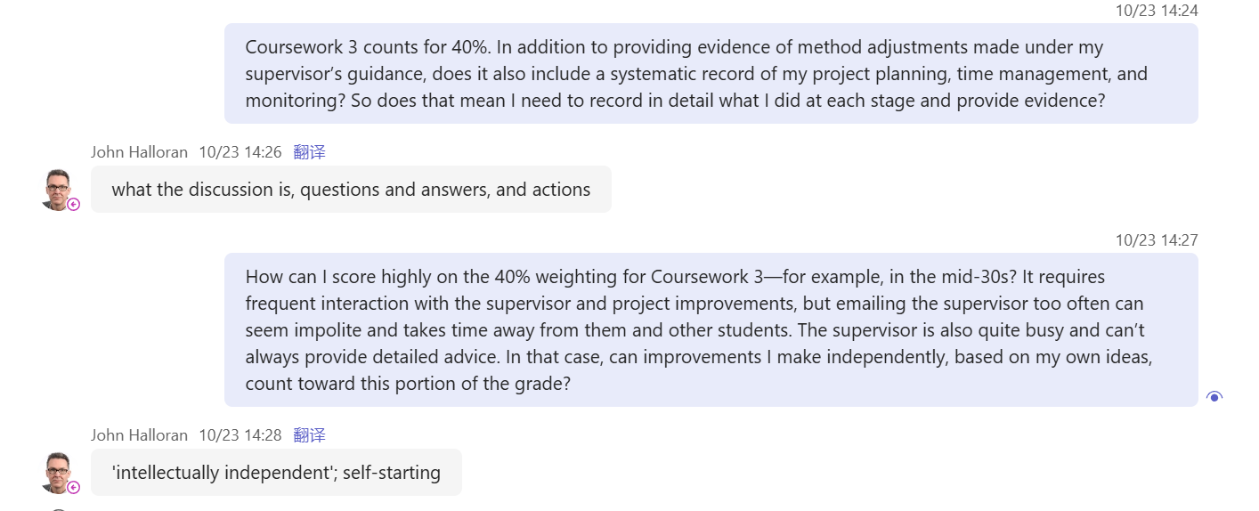
Answer
- Yes, and supervisor recommended a machine learning book.

- What you should do is summarise what we discussed and why we discussed it. This includes which questions I asked you and how you answered them, and which questions you asked me and how I answered them—write all of this down.
- Supervision is only one part of the work. You need to engage actively with the supervision, but you also have to demonstrate your own academic independence.

Actions for next week
Provide an in-depth, technically detailed explanation of how kNN, Random Forest, and InceptionTime work.

Email
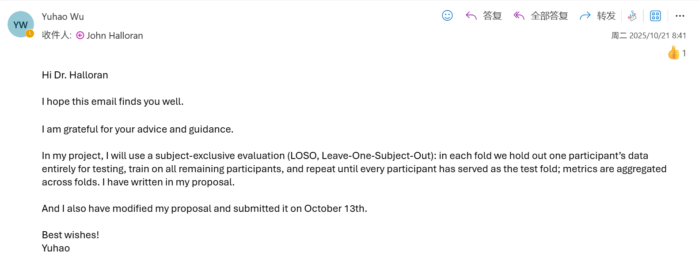

Computing Project
WORK DONE
1. The preprocessing of the LARa dataset, and the training and testing of 6 models (knn, random forest, inceptiontime, tst, minirocket, multirocket) on two datasets.
2. Preparing for the work of designing a new model.

Issues and challenges
- MultiRocket trains slowly on the RealWorld dataset. RealWorld has 15 folds in total, and MultiRocket takes at least three hours to run for each fold.
- For the LARa dataset preprocessing, I have to manually enter the fold each time, which is very inconvenient. Previously, I used a single-fold mode for quick testing, where each fold had to be entered and run manually. Because LARa has 8 folds, training 10 models would require 80 manual runs, which is too time-consuming. Therefore, an automatic version that runs all 8 folds should be developed.

Actions for next week
Use MiniRocket, MultiRocket, and TST to complete training and testing on all folds of the LARa dataset, summarise the results, and report them to my supervisor.
Read the machine learning book recommended by my supervisor.

Link to recording
https://livecoventryac-my.sharepoint.com/:v:/g/personal/wuy176_uni_coventry_ac_uk/IQBMGpJdAegtR6ez_7kyIOrrAa9XlIXekBbaoNtcXco_3H8?e=Y2VWrD&nav=eyJyZWZlcnJhbEluZm8iOnsicmVmZXJyYWxBcHAiOiJTdHJlYW1XZWJBcHAiLCJyZWZlcnJhbFZpZXciOiJTaGFyZURpYWxvZy1MaW5rIiwicmVmZXJyYWxBcHBQbGF0Zm9ybSI6IldlYiIsInJlZmVycmFsTW9kZSI6InZpZXcifX0%3D

